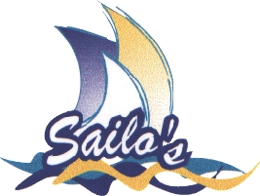 | Taree Aquatic Club Trailer Yacht Info
 | 31st Manning Marathon Regatta

Sunday 24th January 2016

Trailer Yachts competing in the Manning Marathon are invited to “make a weekend of it” and join with local and visiting yachts in a cruise down river from Taree to Manning Point on Saturday 23rd January 2016.

Note: Bridge height clearance is 12m.

The proposed program is:

Saturday

Rig and launch at Taree – the ramp is located in Stevenson Street down from Kentucky Fried Chicken.

1130 Cruise to Manning Point. Depending on conditions, the trip should take 3-4 hours. There are numerous jetties and anchorages at Manning Point.

Dinner at Manning Point Bowling Club and Manning Point Marina
Following dinner and afters, depending on conditions it may be necessary to move yachts for overnight.

Sunday

0900-1100 Beach Entries $45 per yacht
Includes one printed T-shirt

- Approximately
Race briefing

1200 Non Spinnaker Trailer yacht start

1230 Spinnaker Division Trailer yacht start

1300-1400 Line Honours contenders start

1700-1800 Presentation and refreshments Taree Aquatic Club after retrieval and unrigging

If you intend to have dinner at the Taree Aquatic Club, it is advisable to book early. Phone the club: 6552 1435

