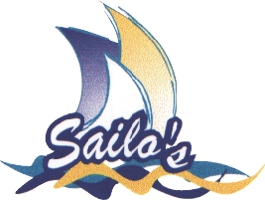 | Taree Aquatic Club Notice of Race
 | 31st Manning Marathon Regatta

Saturday 23rd January 2016
All Class Sailing Race at Manning Point - Beach entries $6. 2.30pm Start
Sunday 24th January 2016
Manning Marathon
Manning Point to Taree
OPEN TO ALL SAILING CLASSES
Total prize value in excess of $1200
Entry | $35 per craft for entries received before 23rd January 2016 (includes 1 printed T shirt)  Extra shirts available at $15 ea.  Junior skipper (under 16) entries $20 including T shirt. (Junior Beach Entries $30)  Club Secretaries will have entry forms or visit the Website.  Post Entries to:  Race Secretary, Taree Aquatic Club Sailing Committee, PO Box 908, TAREE NSW 2430.
 | Beach Entries $45 | 9am to 11am on race day at Manning Point.
Classes | Class comprises five or more of the same craft.  Prize for first over the line (Cock of the River)  Prizes for each class.
Facilities | Ramp and rigging area near starting area.  Caravan Parks nearby.  Ocean Caravan Park 02 6553 2624  Weeroona Caravan Park 02 6553 2635  Snacks, light meals and drinks available at Manning Point Marina and Manning Point Store.  Refreshments are available after the race at Taree Aquatic Club.  If you intend to have dinner at the Taree Aquatic Club on the Sunday night, it is advisable to book early. Phone the club: 6552 1435
Start | Briefing approximately 11am on the beach.  Start times:  - Trailer Yacht (No Spinnaker) - no earlier than 12 noon  - All other Yachts - no earlier than 12:30pm  - Line Honours - no earlier than 1pm (start time will depend on weather conditions).
Want More Information?
www.sailos.info | Phone: George Hughes- (02) 6552 2872  or email marathon@sailos.info

