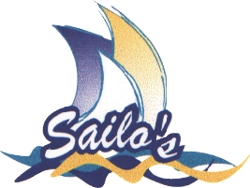 | Taree Aquatic Club Notice of Race
 | 31st Manning Marathon Regatta

Manning Marathon
Junior Division
Sunday 24th January 2016
Croki to Taree
OPEN TO ALL JUNIOR SAILING CLASSES

Entry | Junior skipper (under 16) entries $20 including T shirt for entries received prior to 23rd January 2016.  Extra shirts available at $15 ea.  Club Secretaries will have entry forms or visit the Website.  Post Entries to:  Race Secretary, Taree Aquatic Club Sailing Committee, PO Box 908, TAREE NSW 2430.
 | Junior Beach Entries $30, | 9am to 11am on race day at Croki.
Classes | Class comprises five or more of the same craft.  Prizes for each class.
Facilities | Ramp and rigging area near starting area.  Caravan Parks nearby.  Croki Caravan and Tourist Park 02 6556 3274  www.croki.com.au  Refreshments are available after the race at Taree Aquatic Club.  If you intend to have dinner at the Taree Aquatic Club on the Sunday night, it is advisable to book early. Phone the club: 6552 1435
Start | Briefing approximately 11am on the beach.  12:00pm start.
More Information?
www.sailos.info | Phone: Cassie Cause- 02 6550 0234 (ah)  or email marathon@sailos.info

